AngularJS

<head>
<script src = "https://ajax.googleapis.com/ajax/libs/angularjs/1.5.2/angular.min.js"></script>
</head>

We have included the AngularJS JavaScript file in the HTML page so we can use AngularJS −

Next we tell what part of the HTML contains the AngularJS app. This done by adding the ng-app attribute to the root HTML element of the AngularJS app. You can either add it to html element or body element as shown below −
<body ng-app = "myapp">
</body>

View:
<div ng-controller = "HelloController" >
<h2>Welcome {{helloTo.title}} to the world of Tutorialspoint!</h2>
</div>
ng-controller tells AngularJS what controller to use with this view. helloTo.titletells AngularJS to write the "model" value named helloTo.title to the HTML at this location.

<script>
angular.module("myapp", [])

.controller("HelloController", function($scope) {
$scope.helloTo = {};
$scope.helloTo.title = "AngularJS";
});
</script>
This code registers a controller function named HelloController in the angular module named myapp. The controller function is registered in angular via the angular.module(...).controller(...) function call. The $scope parameter passed to the controller function is the model. The controller function adds a helloTo JavaScript object, and in that object it adds a title field.

When the page is loaded in the browser, following things happen −
- HTML document is loaded into the browser, and evaluated by the browser.
- AngularJS JavaScript file is loaded, the angular global object is created.
- JavaScript which registers controller functions is executed.
- AngularJS scans through the HTML to look for AngularJS apps and views.
- Once view is located, it connects that view to the corresponding controller function. And AngularJS executes the controller functions.
- It then renders the views with data from the model populated by the controller.
- The page is now ready!!!

MVC Architecture:
It is a software design pattern for developing web applications. A Model View Controller pattern is made up of the following three parts −
- Model − It is the lowest level of the pattern responsible for maintaining data.
- View − It is responsible for displaying all or a portion of the data to the user.
- Controller − It is a software Code that controls the interactions between the Model and View.
MVC is popular because it isolates the application logic from the user interface layer and supports separation of concerns. The controller receives all requests for the application and then works with the model to prepare any data needed by the view. The view then uses the data prepared by the controller to generate a final presentable response. The MVC abstraction can be graphically represented as follows.
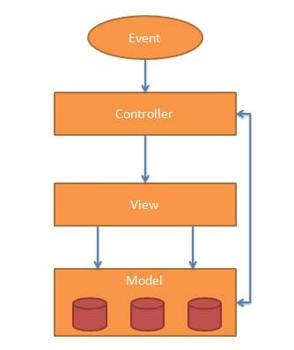
Model:
The model is responsible for managing application data. It responds to the request from view and to the instructions from controller to update itself.

View:
A presentation of data in a particular format, triggered by the controller's decision to present the data. They are script-based template systems such as JSP, ASP, PHP and very easy to integrate with AJAX technology.

Controller:
The controller responds to user input and performs interactions on the data model objects. The controller receives input, validates it, and then performs business operations that modify the state of the data model.

The AngularJS Components
The AngularJS framework can be divided into following three major parts −
- ng-app − This directive defines and links an AngularJS application to HTML.
- ng-model − This directive binds the values of AngularJS application data to HTML input controls.
- ng-bind − This directive binds the AngularJS Application data to HTML tags.

Steps to create AngularJS Application

Step 1 − Load framework
Being a pure JavaScript framework, It can be added using <Script> tag.
<script src = "https://ajax.googleapis.com/ajax/libs/angularjs/1.3.14/angular.min.js">
</script>

Step 2 − Define AngularJS Application using ng-app directive
<div ng-app = "">
...
</div>

Step 3 − Define a model name using ng-model directive
<p>Enter your Name: <input type = "text" ng-model = "name"></p>

Step 4 − Bind the value of above model defined using ng-bind directive.
<p>Hello <span ng-bind = "name"></span>!</p>

How AngularJS integrates with HTML:
- ng-app directive indicates the start of AngularJS application.
- ng-model directive then creates a model variable named "name" which can be used with the html page and within the div having ng-app directive.
- ng-bind then uses the name model to be displayed in the html span tag whenever user input something in the text box.
- Closing</div> tag indicates the end of AngularJS application.

